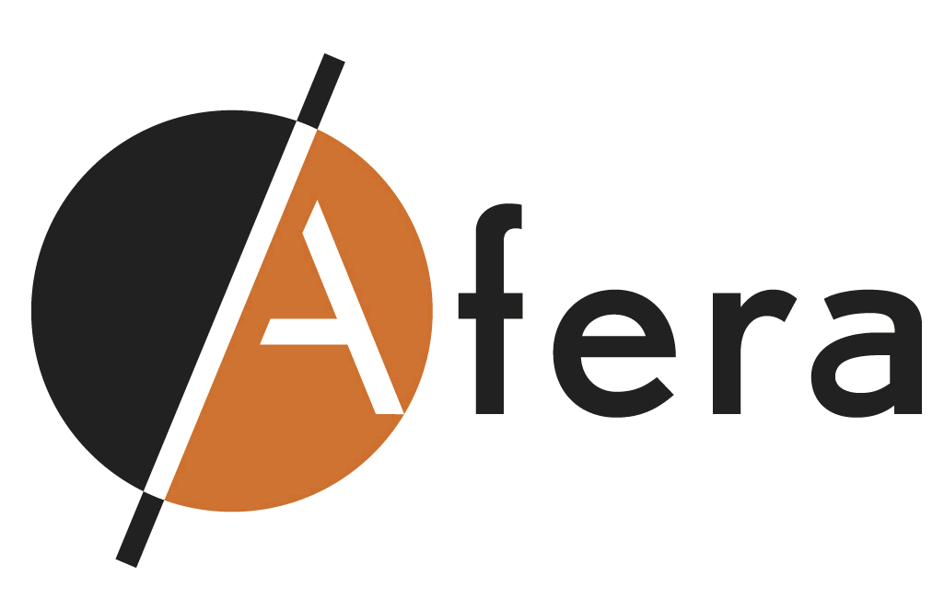
AGENDA

Afera Marketing Committee Meeting
Warwick Barsey Hotel Brussels
5 February 2014, 13.00-17.30 hrs.
Room Barsey III
(lunch available in the meeting room )

- Opening/Agenda/Competition Law Compliance MP

- Minutes and actions meeting 1 October 2013
2.1 Converter input (update on any issues raised by converters) MP
2.2 Formal eligibility and participation rules for MKC membership MP
2.3 Student (engineering field) attending initiative in Tape College update AL
Most actions will be addressed in following Agenda Items

- Update Social Media Initiative to raise Afera’s Profile B. vLoon
  - Status formation virtual marketing team
  - Outcome first online team meeting 15 January 2014
  - Planning content development Q1 – Q3
  - Planning social promotion Q2 –Q3

4. Value adding activities by the MKC MP
4.1 Ideas on how to improve Afera’s activity promotion (communication)
4.2 Brainstorm whether we should run some statistics on industry trends

5. Afera Annual Conference 2014 All
5.1 Review/consideration comments previous conference
5.2 Theme/Topics Conference Programme

6. Afera Website
6.1 Suggestions for improvement All
6.2 Web statistics AL

7. Other matters (please advise any items for inclusion before the meeting) All

- Closure and date next meeting MP

